Questionnaire - Customer Analysis

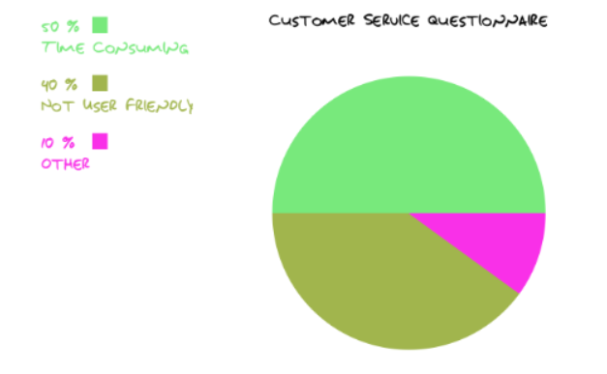

Questionnaires are given out to a total of 100 library’s member of National Library of Malaysia to collect their responses towards the current barcode system. Based on the pie chart above, it shows that most of the library’s member (50%) agreed that the current system which the time consuming is too long. For example, manually chop on the books by librarians while borrowing books is time-consuming.

Beside that 40% of library’ s members are unsatisfied with the current system which are not user friendly. For example, the library’s member difficult to find out the specific book.